19th April 2024

Dear Parents/Carers,

Re: Student Conduct after School

I hope that you enjoyed a restful Easter break.

I am writing to ask you to remind your children that School rules continue to apply on their way to and from School and whenever they are wearing our uniform.

There is a small, but growing, number of students who believe that once they have left the premises, School rules no longer apply to them. This is not the case.

Our Behaviour Policy clearly states that, “students will be expected to take responsibility for their own behaviour by treating all members of staff, pupils and members of the public with respect, following instructions immediately and being aware of and following the School rules both in and out of school.” It also reminds students that good behaviour and conduct outside of the school is just as important as inside, and that they must show manners, respect and consideration for all within our local community.

They must make their way home in an orderly manner, not shouting down the street or hanging around in groups. Whilst this may not be their intention, groups of teenagers can be intimidating for people who do not know them and boisterous behaviour can cause a public nuisance.

I thank you, as always, for your ongoing support.

Yours faithfully,
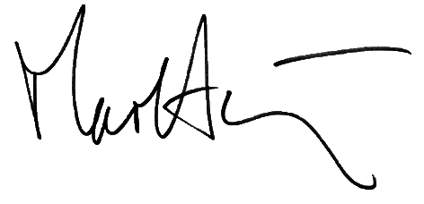

Mr M. Anthony
Headmaster

