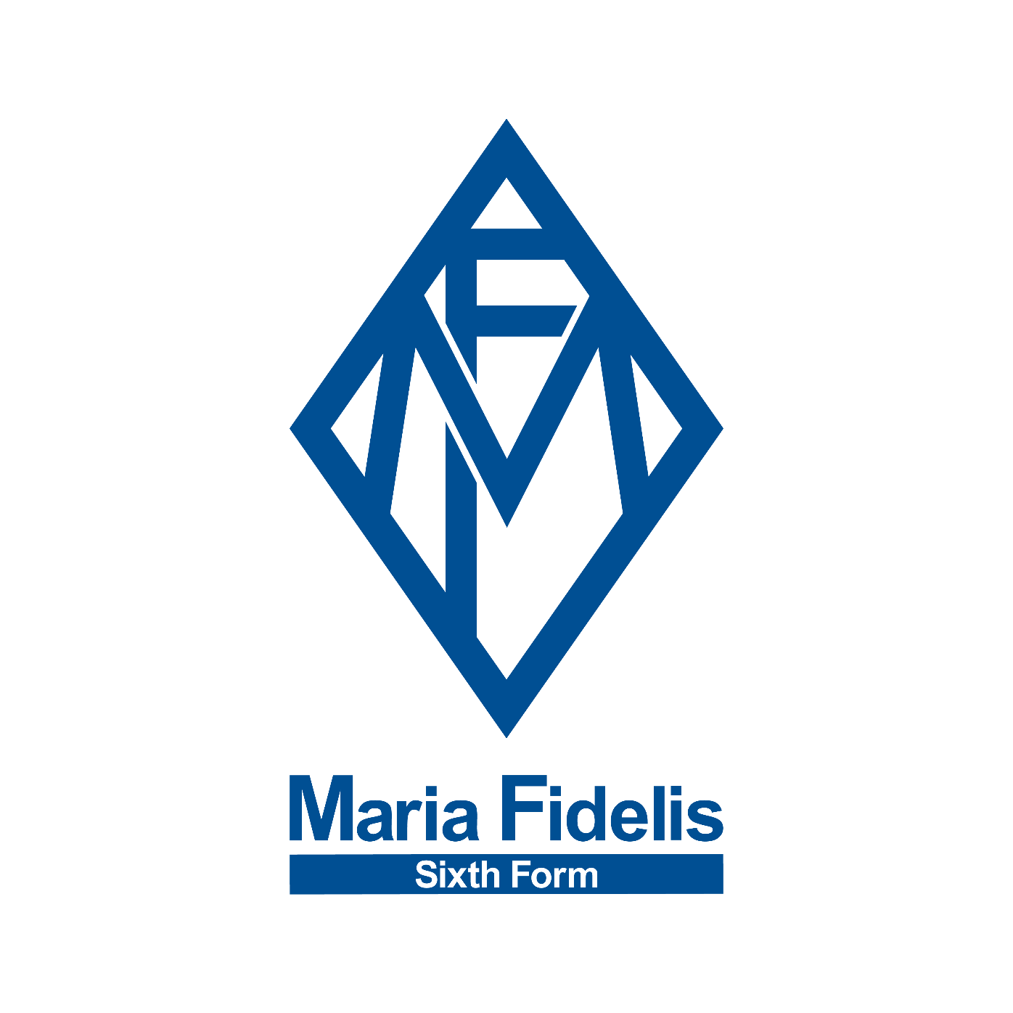
Financial Assistance Forms
2023-2024

Student name: ___________
Year group: _____________

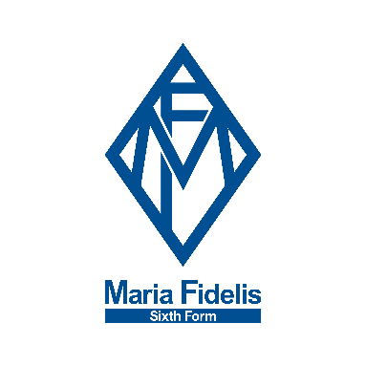

16-19 Bursary Application 2023-2024
Due to your application for Free School Meals, you are eligible to apply for Maria Fidelis Sixth Form Bursary.
Please ensure you have completed all parts of the form, filled in signatures and provided evidence where required.
THIS FORM & SUPPORTING EVIDENCE MUST BE RETURNED ON MONDAY 18th SEPTEMBER 2023

- Personal details
  - Name:

  - Age on 1st September 2023:
  - Year Group (2023/24):
2. School Information
2.1 School attended in Year 11:
2.2 School last attended:
(if not the same as 2.1)
3. Siblings
3.1 Do you have any siblings currently in our Sixth Form?
4. Eligibility – please answer the following questions
4.1 I am a UK National (if yes, please go to section 5) | Yes/no
4.2 I am an EU National (if yes, please go to section 5) | Yes/no
4.3 I, or my family member, has been granted leave to remain | Yes/no
5. Criteria
5.1 Are you living under the care of Health and Social Services or with  foster parents? | Yes/no
5.2 Do you receive Income Support or Income Based Employment and Support Allowance in your own name? (If yes, please provide evidence) | Yes/no
5.3 Are you responsible for the care of a child of your own? | Yes/no
6. Bank Details
Name of Account holder:
Name of bank:
Account number:
Sort code:
7. Household Financial Details
Gross annual household income:  (please provide copies of last P60) | £
Gross annual benefits received:  (please provide copies of proof) | £
Does the applicant receive Free School Meals (please provide proof) | Yes / no
8. Declaration
8.1 Student Declaration
I confirm that the information I have given on this form is correct and complete to the best of my knowledge and belief.
I confirm that I have submitted supporting evidence documentation in accordance with the guidance notes.

Signature: Date:

8.2 Declaration for the person filling out household information
I confirm that the information I have given on this form is correct and complete to the best of my knowledge and belief.

Name: Relationship to applicant:

Signature: Date:

